



Pinterest
SOFTWARE QUALITY ENGINEERING
Test Report

Group Members:
Eman-221400069
Zarish-231400133
Zoya Khalid-221400094
Sarwat Naveed-221400009



Pinterest app

Pinterest is a visual discovery and bookmarking app that allows users to find and save creative ideas using images called "Pins." Users can create boards to organize Pins by topics like recipes, fashion, travel, and more. The app helps users explore content based on their interests. It supports features like search, pinning, sharing, and following other users. Pinterest is available on mobile devices and web browsers.
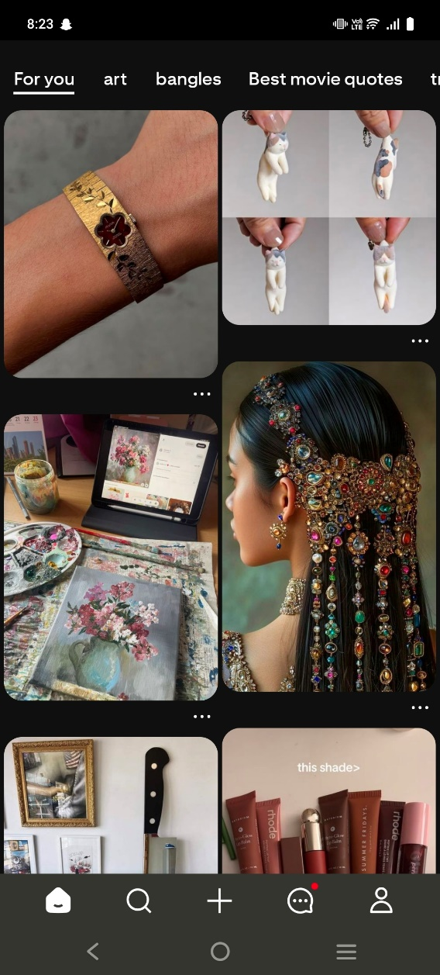
Functionalities:
F1: User Registration and Login
Allows users to create a new account or log in using email, Google, or Facebook.
F2: Home Feed Display
Shows personalized content based on user interests, search history, and saved pins.
F3: Search Functionality
Enables users to search for pins, boards, or profiles using keywords or categories.
F4: Pin Saving
Allows users to save pins to their boards for later viewing or organization.
F5: Board Creation
Allows users to create custom boards to organize pins by themes like recipes, fashion, or travel.
F6: Group Boards
Allows users to collaborate with others by saving and managing pins on a shared board.
F7: Pinterest Lens (Visual Search)
Allows users to search for pins using their phone camera to identify real-world objects and find visual matches.
F8: Rich Pins
Allows users to view enhanced pins with additional information like product details, recipes, or article summaries directly on the pin.
F9: Follow Feature
Allows users to follow specific boards or entire profiles to receive updates on new pins.
F10: Shopping Pins
Allows users to identify products in pins and view price, availability, and purchase links.
F11: Notifications & Activity
Allows users to receive alerts for likes, comments, new followers, pin saves, and board invitations.
F12: Report or Flag Content
Allows users to report inappropriate or harmful pins to Pinterest moderators.
F13: Language and Region Settings
Allows users to customize their app language and location to receive region-specific content.
F14: Private Boards
Allows users to create private boards that are only accessible to board owners or invited users.
F15: Account Deletion
Allows users to permanently delete their account and all associated personal data upon request.

Quality attributes:
1. Security:
Security is one of the quality attribute that tells us that how much secure the app should. It should provide security to the user data so user can trust the product and when user perspective is fullfill than the buissness atomatically grow.
For Pinterest application security must me concidered because it has large amount of user data like saved content and user’s browsing history. In it users have personal profiles and user generates the content in it so it is hard to manage security in it and should provide security against external links that are used in the posts that called rich post in Pinterest.
2. Portability:
This quality attribute is very important as it cheacks on the every plateform how the product is working, is it causing responsivesness error or it show responsiveness on every plateform.
For Pinterest application it runs on multiple plateforms like android, IOS and web as well so checking that if it is giving same results on every device or causing issues in the application. If it is providing multiplateform product than it should be compatible for all it must show responsiveness to every device.
3. Efficiency:
This attribute checks the performance of an software application in terms of speed, responsiveness and how the resources are managing in the product. It checks that if the app runs fast and give quick output to the input of the users.
For Pinterest application it’s core functionalities are saving content and discovering content. If app loads slowly and lags while runing so it must affect user engagement.
4. Understandability:
It is about that how user can understant the application. If it is easy for every type of user or not. Product should be like that if a first-time user uses it, it should provide easy and smooth understanding of what it is about.
For Pinterest application the concepts like Pins and Boards may feels difficult to understand and cause confusion in usin the application that why it does not attract much users and also still many features of it are hidden for many users like it have difficult interface.

5. Usability:
It checks that how easily a user can interact, uses and enjoy the product that a device is working properly all the functions are working well how beautiful the product is.
For Pinterest application, it is rich in content so usability is important for it as it is visually beautiful and eye-catching and also for user expirience. By this user get comfortable with app and Pinterest has a wide user base as people of all ages are using it.

Testing Technique:
For our selected app we choose to follow Agile testing techniques.
Reason:
- Continuous updating is one of the main reasons of using agile testing techniques. In Pinterest app updates are continuously performing.
- Agile techniques are also good in entertaining software’s like this because with the passage of time user needs are kept changing and modernization.
- When agile is used in any project then it means that continuous testing is perform. From the starting of the project to the deployment of the project should be continuously tested. By this project become flexible.
- By this cost is reduce and project is delivered on time which improve quality of the project.
- By this customer is satisfied and it increase the product market value as well.
Agile testing techniques:
Behavioral driven Development:
In Pinterest App where there is a complex structure of saving pins, creating boards and for online shopping using pins. This structure is so complex for the user who’s using the app first time.
So, we should use the agile technique (Behavioral driven development) in our app, which is good to explain the complex requirements into the easy language. Like, if we have the requirement of having a board like Pinterest have it as the main feature of it. By applying the Behavioral driven development technique, we can write this requirement as, there should be a feature named as board in which a person can save all the relative pins and named them as they want which help them to find the same types of pins under one board.
Exploratory Testing:
Pinterest app provides creative and visual interactive platform for the users.
So, we use Exploratory testing to identify user needs and issues they are facing while using the app and by understanding that, we enhance or update those features that causes difficulty for the users. By using this we continuously identifying and resolving the issues that users experiencing through their feedback and increase the quality of our app.
Session-based testing:
In Pinterest app has many features and focuses on visual aesthetics in which users can explore, save, pin and share content in many different ways. So, session-based testing is important in it.
Session-based testing is the structured form of exploratory testing. In its sessions are made and specific time limit or time frames are set in which testing is performed. Like, if you check the feature of saving pin then you choose a specific time session like any 10 to 5 hours of one day in which you have to check every possibility that can occur in that time and after that note down the bugs and problems in this way session-based testing helps us finding errors and bugs which can help team to resolve it quickly.
Pair Testing:
In Pinterest app, there are features that are collaborative and with different accounts interactions. There are sharing of board features and sharing content in different ways.
So, we use Pair testing for which two people usually a tester and a developer or two testers test the same feature together on the same system. This helps in combining two different perspectives for which one may focus on functionality, while the other focuses on usability or edge cases. For example, when testing the feature of pinning an image, one person can explore the front-end flow and the other can observe the back-end behavior. Pair testing is very useful when testing new or complex features, such as creating boards, linking external websites, or checking user interactions. It encourages real-time discussion and allows for quicker feedback. In this way, pair testing helps in early identification of issues, reduces miscommunication between teams, and improves the overall quality of the app through collaborative efforts.

Test Automation Framework:
Our Pinterest app has many users across the world and all users may use the app on different operating systems like IOS, android and also on website so because of that large numbers of audience, testing it manually after every small update or version release must be difficult and time taking therefore the app uses automation frameworks which are the structured guideline or standards used for automation testing of the app for each test case which basically tell us what to test, how to test and expected result from each test.
To ensure and maintain the quality of the product and faster delivery of every version or small update without or less chances of errors we need automated testing because testing manually not give 100 percent accurate result because of human errors although every testing technique should not guarantee 100 percent accuracy but testing the app using automated frameworks save the time and have less chances of errors.
Since, Pinterest updates its app after small duration of time so, automation makes sure that new changes don’t affect the existing features of the app and run the existing and new updates without any problem. Without automation frameworks, every testing would be slow, incomplete and containing some errors.
By using all these testing techniques our app should work more accurately and quickly after every update or version release.

Testcases
Scenario 1:
User Registration and Login: Allows users to create a new account or log in using email, Google, or Facebook.
Test Scenario ID |  | S1 |  |  | Testcase ID |  | T1, T2, T3, T4, T5 |  | 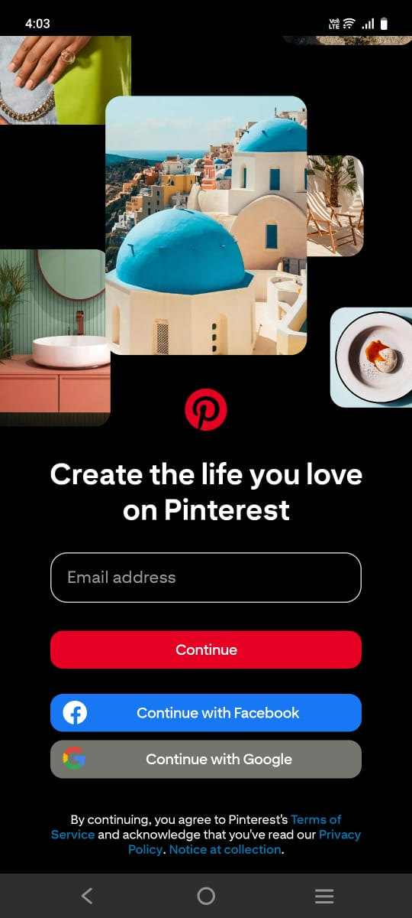
Testcase Description |  | 1- User enter right email and right password.  2- User enter right email and wrong password.  3- User enter wrong email and Right password.  4- User enter wrong email and wrong password.  5- Login with valid Facebook account.  6- Login with valid Google account. |  |  | Test Priority |  | High
Pre-Requisite |  | Access to the app |  |  | Post-Requisite |  | Account is created/ Account is open.
Test Execution Steps
- User access the system.
- User input the valid email and password.
- User can input through Facebook account.
- User can input through Google account.
- User if has account before than can login the account.
- User should click on the create account button.
- User should click on the login button if already have account.
S. No | Action |  | Input |  |  | Expected Output |  | Actual Output | Test Browser | Test Result | Test-Comments
T1 | Taking user input |  | Register with valid email | Register with valid Password |  | New account created. |  | New account is created. | Android app | Pass | Registration is valid
T2 | Taking user input. |  | Login with valid email | Login with valid password. |  | User logged in. |  | User logged in. | Android user. | Pass | Login is valid
T3 | Login with google account |  | Login with valid google account | Login with valid Facebook account |  | User logged in |  | User logged in | Android user | Pass | Login is valid
T4 | Taking user input |  | Login with right email | Login with wrong password |  | User get error msg of wrong password |  | User get error msg of wrong password | Android user | Pass | Login is invalid.
T5 | Taking user input |  | Login with wrong email | Login with right password |  | User get error msg that one of the things is wrong |  | User get error msg that one of the things is wrong | Android user | Pass | Login is invalid.

Scenario 2:
Home Feed Display: Shows personalized content based on user interests, search history, and saved pins
Test Scenario ID |  | S2 |  |  | Testcase ID |  | T1, T2, T3, T4, T5 |  |  | 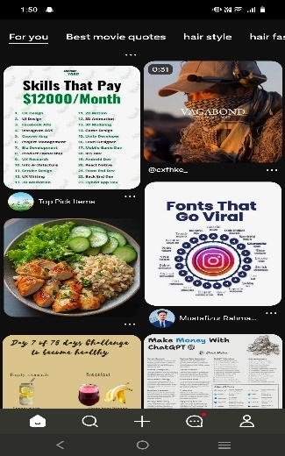
Testcase Description |  | 1-Feed display user interest after logged in.  2- Feed update on the basis of interests.  3- Feed is according to the saved pins.  4- Feed is according to the search history of the user.  5- Feed updates according to interest when reload. |  |  | Test Priority |  | High
Pre-Requisite |  | User should use app and save pins according to interest |  |  | Post-Requisite |  | Content should update according to interest.
Test Execution Steps
- User Logged in into the app.
- User searched anything and feed updated accordingly.
- User saved a pin and feed should be according to the saved pin.
- When user reload the feed show the similar content
S. No | Action |  | Input |  |  | Expected Output |  | Actual Output | Test Browser | Test Result | Test-Comments
T1 | User action |  | Logged in with valid id | Logged in with valid account |  | Home page displayed |  | Home page is displayed | Android app | Pass | User made it to access the app.
T2 | User Searches |  | User made valid searches. | User save the search related pins. |  | Home page updated accordingly |  | Home page shows output related to searches | Android app | Pass | User get what’s he/she is interested in.
T3 | User interact |  | User view same types of pins. | User saved same types of pins. |  | Home page show that types of pins most often |  | Home page show that types of pins most often | Android app | Pass | User get what’s he/she is interested in.
T4 | User interact |  | User view the same types if pins | User does not save those pins |  | Home page show that types of pins most often |  | Home page show that types of pins most often | Android app | Pass | User get what’s he/she is interested in.
T5 | User reload |  | After interaction with pins user directly reload the feed | After interaction with pins user does not reload the app |  | Related to current interest new feed updates |  | Related to current interest new feed updates | Android app | Pass | User get what’s he/she is interested in.

Scenario 3:
Search Functionality: Enables users to search for pins, boards, or profiles using keywords or categories.
Test Scenario ID |  | S3 |  |  | Testcase ID |  |  | T1, T2, T3, T4, T5 |  | 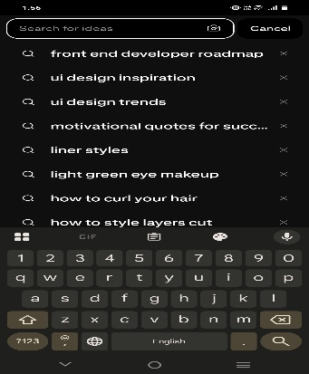
Testcase Description |  | 1-Search for pin using valid Keywords.  2- Search for boards using valid Keywords.  3- Search for user profile by username.  4-Search for invalid username. |  |  | Test Priority |  |  | High
Pre-Requisite |  | User must be connected to internet. |  |  | Post-Requisite |  |  | Result should be provided based on searches.
Test Execution Steps
- User logged in into the app.
- User navigate to the search bar.
- Enter a valid keyword.
- Click on search button.
- Valid results are provided.
- Open pins you want.
S. No | Action |  | Input |  |  | Expected Output | Actual Output |  | Test Browser | Test Result | Test-Comments
T1 | User Searches |  | User searches pins with relevant keyword | User searches profile with relevant keyword |  | Searched material provided | Searched material is provided. |  | Android app | Pass | Results are provided.
T2 | User Searches |  | User searches  boards with relevant keyword | User search boards with relevant keyword |  | Boards occur that are more relevant to the keyword. | Boards occur that are more relevant to the keyword. |  | Android app | Pass | Results are provided.
T3 | User Searches |  | User searches  profiles with right id name | User searches profiles with wrong id name |  | Relevant profiles are provided | Relevant to search profile is provided. |  | Android app | Pass | Results are provided.
T4 | User Searches |  | User searches pins with irrelevant keyword | User searches profile with irrelevant keyword |  | Should provide error message | Random pins are displayed |  | Android app | Fail | Results are wrong
T5 | User Searches |  | User searches  boards with relevant keyword | User search boards with relevant keyword |  | Should provide error message | Random things displayed |  | Android app | Fail | Results are wrong.

Scenario 4:
Pin Saving: Allows users to save pins to their boards for later viewing or organizing.
Test Scenario ID |  | S4 |  |  | Testcase ID |  | T1, T2, T3, T4, T5 |  |  | 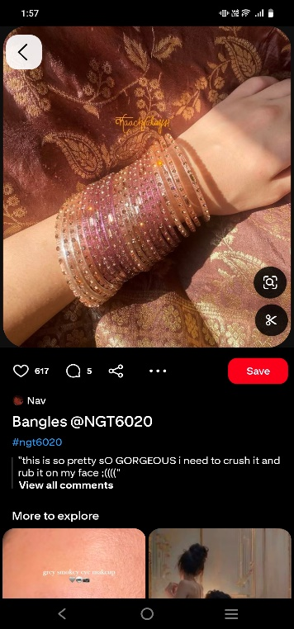
Testcase Description |  | 1-User open the app and select the pins.  2-User taps to “Save” Button on a pins  3-User select existing board to save the pins or create the board during add the pins.  4-User check the pins saved after open o pen the selected board.  5-User save multiple pins in the same boards |  |  | Test Priority |  | High
Pre-Requisite |  | User must be logged into the app and have a good internet connection.  User at least have on board already created. |  |  | Post-Requisite |  | Selected pins are saved to the boards.  Save pins appear under the board when viewed later
Test Execution Steps
1- Must be logged in Pinterest App.
2- Tap the pin user want to save
3- Tap on save Button.
4- Select existing board or tap create board to make a new one.
5- Confirm the pins is saved.
6- Go to select board and verify the saved pins is there.
S. No | Action |  | Input |  |  | Expected Output |  | Actual Output | Test Browser | Test Result | Test-Comments
T1 | User open Pinterest App |  | Enter username and Password | Tap on “Login” or “Continue” button |  | Scroll to check the saved pin |  | As expected, | Android app | Pass | Login worked fine
T2 | User Search or browse for a pin. |  | Type anything | Scroll through the search results |  | Scroll to check the saved pin |  | As expected, | Android app | Pass
T3 | User Tap on pins |  | Select any pins | Tap on pin image to view details |  | Scroll to check the saved pin |  | Saved pin is visible in the board | Android app | Pass | Pin opened fine
T4 | User Tap on Save button |  | Choose board or create board | Confirm saving by tapping “Done” or “Save” |  | Pin is saved to the board |  | Pin was saved to the selected board | Android app | Pass | Pin saved successfully
T5 | User open board to verify |  | Tap on board where pins are saved | Scroll to check the saved pin |  | Saved pin is visible in the board |  | As expected, | Android app | Pass | Pin found in board

Scenario 5:
Board Creation: Allows users to create custom boards to organize pins by themes like recipes, fashion, or travel.
Test Scenario ID |  | S5 |  |  | Testcase ID |  |  | T1, T2, T3, T4, T5 |  | 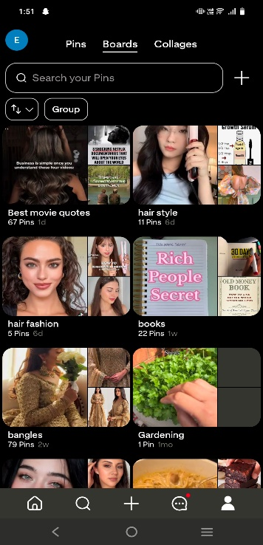
Testcase Description |  | 1-User click on “Create Board “icons to create  new board.  2-User enters name to the boards, such as fashion, traveling or cooking recipe.  3-New Board is creating successfully with the name provided by user and added to user’s board list.  4-User can save now relevant pins according the selected theme of boards. |  |  | Test Priority |  |  | High
Pre-Requisite |  | User must be logged in into the app and have a good internet |  |  | Post-Requisite |  |  | Board should be created with the given name and shown in the user board list
Test Execution Steps:
1-Must be logged In into the Pinterest App.
2-Click on “Create Board” Button.
3-Enter a name or theme for a new Board (fashion, travelling).
4-Boards Successfully create and appear to user Board list
5-Open the user board list and confirm it that the new board is created or visible.
S. No | Action |  | Input |  |  | Expected Output | Actual Output |  | Test Browser | Test Result | Test-Comments
T1 | User open Pinterest App |  | Enter name and Password | Tap login button |  | App opens with home screen | As expected, |  | Android app | Pass | App opened successfully
T2 | User Tap create Board |  | Click on create Board Button | Tap on "+" icon |  | Create board screen appears | As expected, |  | Android app | Pass | Create screen opened fine
T3 | User enter Board name |  | Type theme name (fashion) | Select category if shown |  | Board name shown in the input fields | Name entered, but no category shown |  | Android app | Pass
T4 | User taps on Create |  | Click on “Create” to save board | Wait for board to save |  | Save the boards | As expected, |  | Android app | Pass | Board created successfully
T5 | User confirm Board |  | Open board check that board is visible | Tap on newly created board |  | In Board List screen new board is created and visible | Board was listed and opened properly |  | Android app | Pass | Board listed and opened

Scenario 6:
Group Boards: Allows users to collaborate with others by saving and managing pins on a shared board.
Test Scenario ID |  | S6 |  |  | Testcase ID |  |  | T1, T2, T3, T4, T5 |  | 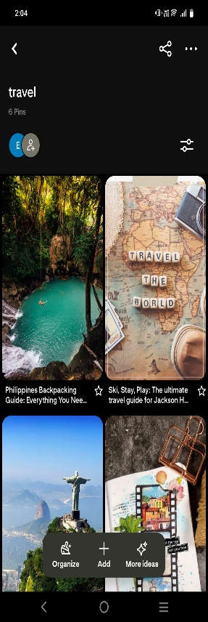
Testcase Description |  | 1-User open an existing board or click “Invite “button to add a collaboration.  2-User enter email or username of the collaboration and send the invite.  3-Collaborator get the invitation and accept it  Then collaborator save the pin on shared board.  4-Board creator check the board that that collaborator pin is showing or not in the board  5-Both Board Creator and collaborator view or edit and delete the pins. |  |  | Test Priority |  |  | High
Pre-Requisite |  | A board should be already be created by user |  |  | Post-Requisite |  |  | Board Collaborator should be accessing the shared board  Both creator and collaborator can manage or add the pin in the board
Test Execution Steps:
1-Go to the Board Section.
2-Open Existing Board
3-Tap on the invite icon button
4-Enter username of collaborator
5-Tap on send Invitation button and ask person to accept it
6-As the collaborator open the board
7-Save a pin in the board and board owner check if the collaborator pin is visible
S. No | Action |  | Input |  |  | Expected Output | Actual Output |  | Test Browser | Test Result | Test-Comments
T1 | User Go to Board |  | Select create board | Open existing board |  | Selected board opens | As expected, |  | Android app | Pass | Board opened
T2 | User Tap Collaborator option |  | Click Invite Icon | Tap on Collaborator tab |  | Invite screen appear | As expected, |  | Android app | Pass | Option opened
T3 | User Tap Collaborator Info |  | Type Collaborator username | Check profile info |  | Collaborator info is shown | Username shown with details |  | Android app | Pass | Info visible
T4 | User send Invitation |  | Tap invite or Add button | Confirm invitation sent |  | Invite is sent successfully | As expected, |  | Android app | Pass | Invite sent
T5 | User Verify Collaboration |  | Log in as Collaborator | Open shared screen |  | Shared board is visible | As expected, |  | Android app | Pass | Board shared

Scenario 7:
Pinterest Lens (Visual Search): Allows users to search for pins using their phone camera to identify real-world objects and find visual matches.
Test Scenario ID |  | S7 |  |  | Testcase ID |  |  | T1, T2, T3, T4, T5 |  |  | 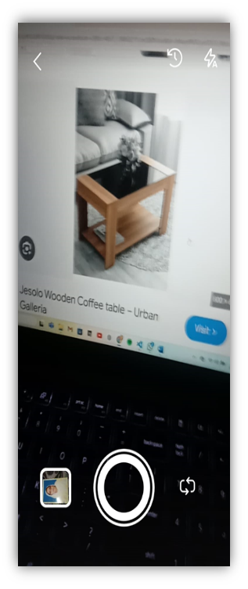
Testcase Description |  | 1-User open the Pinterest app and taps on camera  2-User show a product to the camera like shoes and a chair.  3-User take a photo using the Pinterest Lens.  4-App scan the image and show similar or related pins  5-User taps the suggested pins |  |  | Test Priority |  |  | High
Pre-Requisite |  | User must be logged in the App  App has permission to use the camera |  |  | Post-Requisite |  |  | App should be display visually similar pins based on given photo.  User can tap and view the suggested pins
Test Execution Steps:
1-Must be logged in the App.
2-Taps on the camera icons on the search bar.
3-Allow camera permission if asked.
4-3-Point the camera at real product like shoes.
5-Capture the photo and wait the app to scan the image.
6-Check similar pin appear based on the product.
7-Tap the suggested pin and view it.
S. No | Action |  | Input |  |  | Expected Output | Actual Output |  | Test Browser | Test Result |  | Test-Comments
T1 | User open Pinterest Lens |  | Tap camera icon | Allow camera permission |  | Camera view opens | As expected, |  | Android app | Pass |  | Lens opened
T2 | User show camera to product |  | To real-world item like shoes | Adjust angle |  | Product is shown in preview | As expected, |  | Android app | Pass |  | Object detected
T3 | User Capture image |  | Tap the click button | | Hold camera still |  | Image is taken and start processing | As expected, |  | Android app | Pass
T4 | User View visual match |  | Wait for result | Let system process image |  | Similar pins appear on screen | Pin details open |  | Android app | Pass |  | Pins matched
T5 | User open pins |  | Tap on matching pins | View details |  | Pin details open | As expected, |  | Android app | Pass |  | Pin opened

Scenario 8:
Rich Pins: Allows users to view enhanced pins with additional information like product details, recipes, or article summaries directly on the pin or they can take directly to the original website.

Test Scenario ID |  | S8 |  |  | Testcase ID |  |  | T1, T2, T3, T4, T5 |  |  | 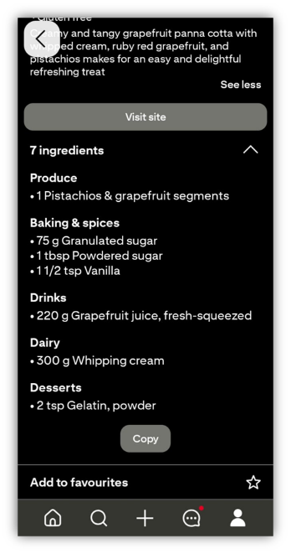
Testcase Description |  | 1- User opens a product Rich Pin.  2- User opens a recipe Rich Pin.  3- User opens an article Rich Pin.  4- User clicks link to original website.  5- User checks metadata. |  |  | Test Priority |  |  | High
Pre-Requisite |  | User must be logged in with internet access. |  |  | Post-Requisite |  |  | User can view extra info or redirected to the original website.
Test Execution Steps:
- User logins to Pinterest app.
- Navigate to any Rich Pin.
- Tap and open it.
- View details or click website link.
- Verify metadata.
S. No | Action |  | Input |  |  | Expected Output | Actual Output |  | Test Browser | Test Result |  | Test-Comments
T1 | Open Pin |  | Tap product Rich pin | Choose any product Pin |  | Product info (price, availability) shown | As Expected, |  | Android app | Pass |  | Shopping pin opened
T2 | Open Pin |  | Tap recipe Rich Pin | Select food related Pin |  | Recipe steps & ingredients shown | As Expected, |  | Android app | Pass |  | Info displayed correctly
T3 | Open Pin |  | Tap article Rich Pin | Select article Pin |  | Article summary & author info shown | As Expected, |  | Android app | Pass |  | Redirect works fine
T4 | Click Link |  | Click website link | In any Rich Pin |  | User redirected to original website | As Expected, |  | Android app | Pass |  | Page loads properly
T5 | View metadata |  | View Rich Pin info | Check extra details |  | Metadata displayed (e.g., brand, price) | As Expected, |  | Android app | Pass |  | Product added to cart

Scenario 9:
Follow Feature: Allows users to follow specific boards or entire profiles to receive updates on new pins.

Test Scenario ID |  |  | S9 |  | Testcase ID |  |  | T1, T2, T3, T4, T5 |  |  | 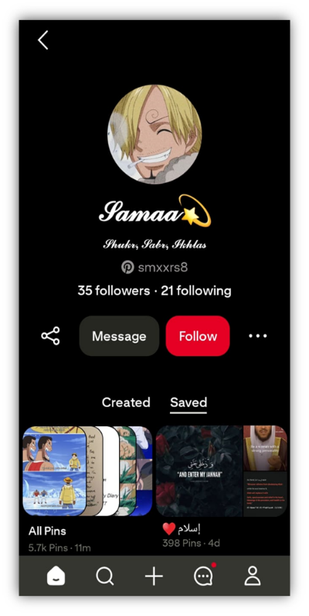
Testcase Description |  |  | 1-User follows a board.  2-User follows a profile.  3-User checks feed for new pins from followed boards/profiles.  4-User unfollows a board.  5-User unfollows a profile. |  | Test Priority |  |  | High
Pre-Requisite |  |  | User must be logged in. |  | Post-Requisite |  |  | Feed updates as per following actions.
Test Execution Steps:
- Login to Pinterest app.
- Navigate to board or profile.
- Tap Follow button.
- Check updates in feed.
- Unfollow and verify changes.

S. No | Action | Input |  |  |  | Expected Output | Actual Output |  | Test Browser | Test Result |  | Test-Comments
T1 | Follow board | Tap Follow button |  | On selected board |  | User starts following board | As Expected, |  | Android app | Pass |  | Board followed successfully
T2 | Follow profile | Tap Follow button |  | On selected profile |  | User starts following profile | As Expected, |  | Android app | Pass |  | Profile followed
T3 | Check feed |  |  | View new content |  | Feed shows pins from followed | As Expected, |  | Android app | Pass |  | Feed updated
  Refresh home feed
T4 | Unfollow board | Tap Unfollow |  | On board page |  | Board unfollowed, no updates | As Expected, |  | Android app | Pass
  Board unfollowed
T5 | Unfollow profile | Tap Unfollow |  | On profile page |  | Profile unfollowed, no updates | As Expected, |  | Android app | Pass |  | Profile unfollowed

Scenario 10:
Shopping Pins: Allows users to identify products in pins and view price, availability, and purchase links.
Test Scenario ID |  | S10 |  |  | Testcase ID |  |  | T1, T2, T3, T4, T5 |  |  | 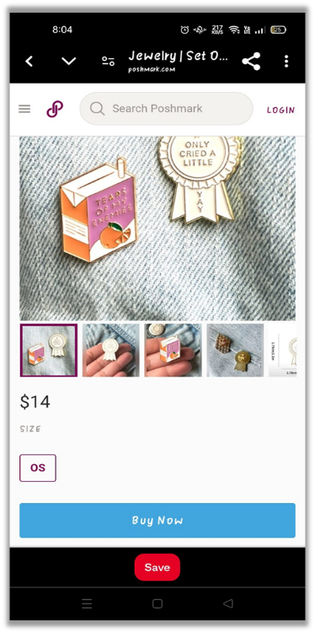
Testcase Description |  | 1-User opens a shopping pin.  2-User views price and availability.  3-User clicks purchase link.  4-User checks redirection to product website.  5-User adds product to cart on merchant site. |  |  | Test Priority |  |  | High
Pre-Requisite |  | User must be logged in with internet access. |  |  | Post-Requisite |  |  | User can proceed to purchase.
Test Execution Steps:
- Login to Pinterest app.
- Find shopping pin.
- View pin details.
- Click purchase link.
- Verify website redirection and cart.
S. No | Action |  | Input |  |  | Expected Output | Actual Output |  | Test Browser | Test Result |  | Test-Comments
T1 | Open pin |  | Tap shopping pin | Select any shopping pin |  | Pin opens with product info | As expected, |  | Android app | Pass |  | Shopping pin opened
T2 | View details |  | Check price/info | On pin screen |  | Price and stock info shown | As expected, |  | Android app | Pass |  | Info displayed correctly
T3 | Click link |  | Tap purchase link | In pin details |  | Redirect to merchant website | As expected, |  | Android app | Pass |  | Redirect works fine
T4 | Check site |  | Browse product | On merchant site |  | Product page loaded | As expected, |  | Android app | Pass |  | Page loads properly
T5 | Add to cart |  | Tap Add to Cart | On merchant page |  | Product added to cart | As expected, |  | Android app | Pass |  | Product added to cart

Scenario 11:
Notifications & Activity: Allows users to receive alerts for likes, comments, new followers, pin saves, and board invitations.
Test Scenario ID |  | S11 |  |  | Testcase ID |  |  | T1, T2, T3, T4, T5 |  |  | 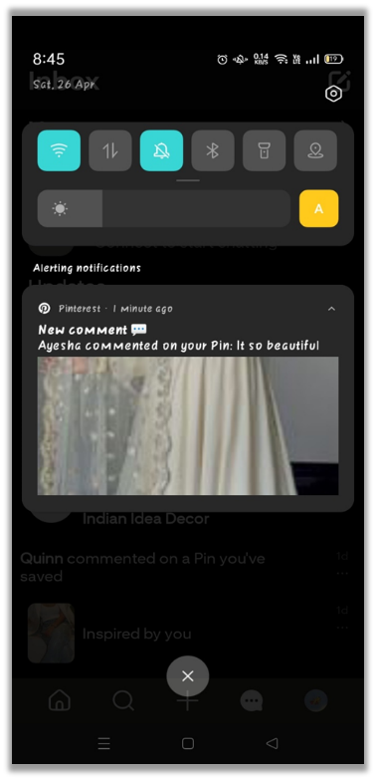
Testcase Description |  | 1-User receives like notification.  2-User receives comment notification.  3-User receives new follower alert.  4-User receives pin save notification.  5-User receives board invite notification. |  |  | Test Priority |  |  | High
Pre-Requisite |  | User must be logged in with internet access. |  |  | Post-Requisite |  |  | Notifications shown in activity tab.
Test Execution Steps
- Login to Pinterest app.
- Perform or wait for interaction (like, comment, etc.).
- Open notifications tab.
- Check received alerts.
- Tap notifications and verify redirection.
S. No | Action |  | Input |  |  | Expected Output | Actual Output |  | Test Browser | Test Result |  | Test-Comments
T1 | Receive like |  | Get pin liked | By another user |  | Like notification received | As Expected, |  | Android app | Pass |  | Like alert shown
T2 | Receive comment |  | Get pin commented | By another user |  | Comment notification received | As Expected, |  | Android app | Pass |  | Comment alert shown
T3 | Receive follower |  | New follower joins | Profile followed |  | Follower notification received | As Expected, |  | Android app | Pass |  | Follower alert shown
T4 | Receive save |  | Pin saved by user | Any of your pin |  | Save notification received | As Expected, |  | Android app | Pass |  | Save alert shown
T5 | Receive invite |  | Board invite sent | By another user |  | Invite notification received | As Expected, |  | Android app | Pass |  | Invite alert shown

Scenario 12:
Report or Flag Content: Allows users to report inappropriate or harmful pins to Pinterest moderators.
Test Scenario ID |  | S12 |  |  | Testcase ID |  |  | T1, T2, T3, T4, T5 |  |  | 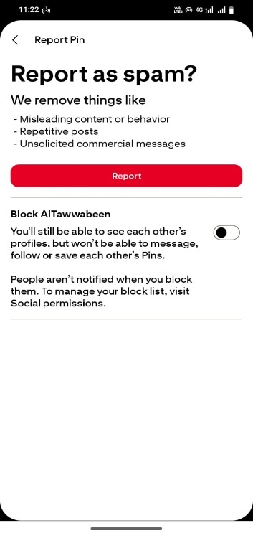
Testcase Description |  | 1. User select the inappropriate or harmful pins.  2. User then select reason for report.  3. Then also show the block option to block that profile of particular person.  4. User click the report button.  5. Check if report is saved. |  |  | Test Priority |  |  | High
Pre-Requisite |  | User must be login to the system and must have an internet connection. |  |  | Post-Requisite |  |  | Content reported successfully.
Test Execution Steps
1. User should login to the system.
2. User select inappropriate or harmful pin.
3. User select the report pin option.
4. User then choose one option from (i.e. spam, self-harm, privacy-violation etc.).
5. User then click the Report button.
6. System then show the successfully reported pin message.
S. No | Action |  | Inputs (Select pin & select reason) |  |  | Expected Output | Actual Output |  | Test Browser | Test Result |  | Test-Comments
T1 | User select the inappropriate or harmful pins. |  | T | F |  | Report modal appears | As Expected, |  | Android App | Pass |  | -
T2 | User then select reason for report. |  | T | T |  | Reason highlighted | As Expected, |  | Android App | Pass |  | -
T3 | Then also show the block option to block that profile of particular person. |  | T | T |  | Profile blocked | As Expected, |  | Android App | Pass |  | -
T4 | User click the report button. |  | T | T |  | Confirmation message shown | As expected, |  | Android App | Pass |  | -
T5 | Check if report is saved. |  | T | T |  | Report saved | As Expected, |  | Android App | Pass |  | Verified in Database

Scenario 13:
Language and Region Settings: Allows users to customize their app language and location to receive region-specific content.
Test Scenario ID |  | S13 |  |  |  | Testcase ID |  | T1, T2, T3, T4, T5 |  |  | 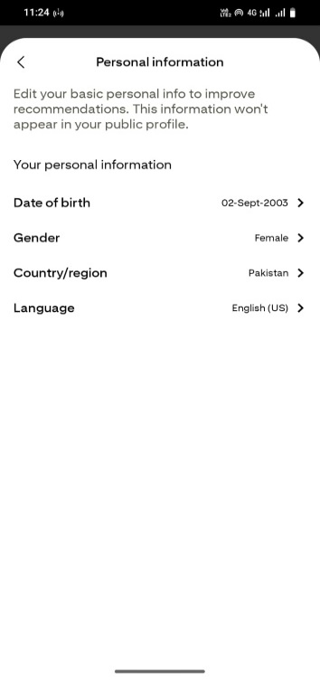
Testcase Description |  | 1. User select the inappropriate or harmful pins.  2. User then select reason for report. Then also show the block option to block that profile of particular person.  3. User click the report button.  4. Check if report is saved.  5. User logout from the system then logged-in again and check the changes if existed or not. |  |  |  | Test Priority |  | Medium
Pre-Requisite |  | User must be login to the system and must have an internet connection. |  |  |  | Post-Requisite |  | Changes saved and applied on system.
Test Execution Steps: 1. User should be login to the system.
2. User select the settings option.
3. User change the language to Urdu.
4. User then change the region to Pakistan.
5. User then click the save changes option.
6. System then show the changes with popup message on the screen.
7. User logout from the system and then again logged-in the changes still remain unchanged.
S. No | Action |  | Inputs (language and region selected) |  | Expected Output |  | Actual Output |  | Test Browser | Test Result |  | Test-Comments
T1 | User navigate to settings option |  | F | F | Settings page opens |  | As Expected, |  | Android App | Pass |  | -
T2 | User then change the language |  | T | F | Interface updates to Urdu |  | As Expected, |  | Android App | Pass |  | -
T3 | User then change the region |  | F | T | Content localized to Pakistan |  | As Expected, |  | Android App | Pass |  | -
T4 | User click the save changes button |  | T | T | Settings applied |  | As Expected, |  | Android App | Pass |  | -
T5 | User logout from the system and then again logged-in the changes still remain unchanged |  | T | T | Same settings applied after login |  | As Expected, |  | Android App | Pass |  | -

Scenario 14:
Private Boards: Allows users to create private boards that are only accessible to board owners or invited users.
Test Scenario ID |  | S14 |  |  | Testcase ID |  |  | T1, T2, T3, T4, T5 |  |  | 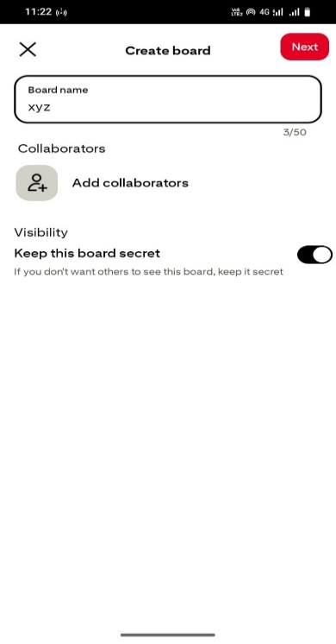
Testcase Description |  | 1. User click the create Board option.  2. System then give option to add any collaborations if interested via Email.  3. Then user click the option to keep this board private.  4. User then ask to add one to more pins to that board.  5. User then check the Done button.  6. Private Board created successfully with collaboration and restriction. |  |  | Test Priority |  |  | Medium
Pre-Requisite |  | User must be login to the system and must have an internet connection. |  |  | Post-Requisite |  |  | Private board created with restriction.
Test Execution Steps
1. User should be login to the system.
2. User click the create Board option.
3. User then click the “keep this Board private” option.
4. User add pins to that private Board.
5. User click add collaboration option to add another user via email invite.
6. System then show the private Board with restrictions.
7. User search that board as a guest then “Board not found” option will be shown to user.
S. No | Action |  | Inputs (Board Name Provided & Private Option Selected) |  |  | Expected Output | Actual Output |  | Test Browser | Test Result |  | Test-Comments
T1 | User click the create Board option. |  | T | F |  | Board creation page or modal appears | As Expected, |  | Android App | Pass |  | -
T2 | User then enable the “keep this Board private” option. |  | T | T |  | Board marked private | As Expected, |  | Android App | Pass |  | -
T3 | User adds the pins to the Board. |  | T | T |  | Pin saved to private board | As Expected, |  | Android App | Pass |  | -
T4 | User share the Board to different users via email invitation |  | T | T |  | Invite sent to another user | As Expected, |  | Android App | Pass |  | -
T5 | User search that Board as a Guest. |  | F | F |  | Board not found | As Expected, |  | Android App | Pass |  | Hidden from public view

Scenario 15:
Account Deletion: Allows users to permanently delete their account and all associated personal data upon request.
Test Scenario ID |  | S15 |  |  | Testcase ID |  |  | T1, T2, T3, T4, T5 |  |  | 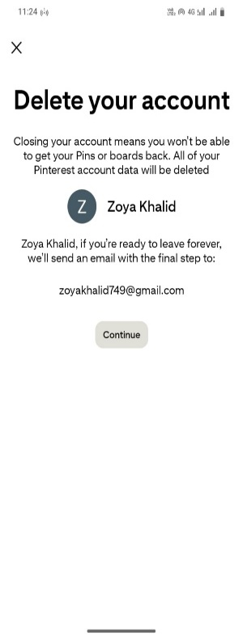
Testcase Description |  | 1. User go to account setting.  2. User then click the delete account Button.  3. System ask for confirmation with reason to delete account.  4. System that send mail to given email Id of account deletion.  5. User then check the deletion by logging-in again to the system with same credentials.  6. User then check email for confirmation. |  |  | Test Priority |  |  | High
Pre-Requisite |  | User must be login to the system and must have an internet connection. |  |  | Post-Requisite |  |  | Permanently deleted account from the system.
Test Execution Steps
1. User should be login to the system.
2. User go to account setting.
3. User then click the delete account Button.
4. User select reason for account deletion.
5. System then send delete account message via email.
6. User again login to system with same credentials for confirmation of account deletion.
7. User then check email either system send email or not.
S. No | Action |  | Input (Logged-in & Email Registered) |  |  | Expected Output | Actual Output |  | Test Browser | Test Result |  | Test-Comments
T1 | User go to account setting option. |  | T | F |  | Settings page loads | As Expected, |  | Android App | Pass |  | -
T2 | User then select reason for account deletion with their all-personal data. |  | T | F |  | Reason selected | As Expected, |  | Android App | Pass |  | -
T3 | User then click the delete account button. |  | T | F |  | Confirmation prompt appears | As Expected, |  | Android App | Pass |  | -
T4 | User then attempted to login again with same credentials. |  | F | T |  | Login fails | As Expected, |  | Android App | Pass |  | Account deleted
T5 | User check email for confirmation. |  | F | F |  | Receive confirmation email | As Expected, |  | Android App | Pass |  | Email received successfully

Traceability Matrix

Quality attributes Traceability Matrix:
Feature id | Feature Description | Usability | Security | Portability | Efficiency | Understandability
F-1 | User Registration and Login | 
F-2 | Home Feed Display |  |  |  | 
F-3 | Search Functionality
F-4 | Pin Saving
F-5 | Board Creation
F-6 | Group Boards
F-7 | Pinterest Lens (Visual Search)
F-8 | Rich Pins
F-9 | Follow Feature
F-10 | Shopping Pins
F-11 | Notifications & Activity
F-12 | Report or Flag Content
F-13 | Language and Region Settings
F-14 | Private Boards
F-15 | Account Deletion

Forward traceability Matrix:

Feature ID | Feature Description | Test ID | Test Case Description
F1 | User Registration and Login | TC-01 | Register with email
F1 | User Registration and Login | TC-02 | Login with Google
F1 | User Registration and Login | TC-03 | Login with Facebook
F2 | Home Feed Display | TC-04 | Verify feed shows based on user interest
F2 | Home Feed Display | TC-05 | Verify saved pins affect feed
F3 | Search Functionality | TC-06 | Search by keyword
F3 | Search Functionality | TC-07 | Search by category
F4 | Pin Saving | TC-08 | Save pin
F4 | Pin Saving | Tc-09 | Saved pin appears in board
F5 | Board Creation | TC-10 | Verify board creation with name
F5 | Board Creation | Tc-11 | Verify new board appears in user’s board list
F6 | Group Boards | TC-12 | Invite to group board
F6 | Group Boards | TC-13 | Multiple users add pins
F7 | Pinterest Lens (Visual Search) | TC-14 | Capture image
F7 | Pinterest Lens (Visual Search) | TC-15 | Show visual match
F8 | Rich Pins | TC-16 | Show extra info
F8 | Rich Pins | TC-17 | Display recipe/article data
F9 | Follow Feature | TC-18 | Follow board
F9 | Follow Feature | TC-19 | Receive updates
F10 | Shopping Pins | TC-20 | Show product details
F10 | Shopping Pins | TC-21 | Product link clickable
F11 | Notifications & Activity | TC-22 | Receive notifications for likes/comments
F11 | Notifications & Activity | TC-23 | Board invites alerts
F12 | Report or Flag Content | TC-24 | Report pin
F12 | Report or Flag Content | TC-25 | Flag appears
F13 | Language and Region Settings | TC-26 | Change language
F13 | Language and Region Settings | TC-27 | Region updates content
F14 | Private Boards | TC-28 | Create private board
F14 | Private Boards | TC-29 | Only invited users see it
F15 | Account Deletion | TC-30 | Delete account
F15 | Account Deletion | TC-31 | All data removed

Backward Traceability Matrix:
Test Case ID | Test Case Description | Feature ID | Feature Description
TC-01 | Register with email | F1 | User Registration and Login
TC-02 | Login with Google | F1 | User Registration and Login
TC-03 | Login with Facebook | F1 | User Registration and Login
TC-04 | Verify feed shows based on user interest | F2 | Home Feed Display
TC-05 | Verify saved pins affect feed | F2 | Home Feed Display
TC-06 | Search by keyword | F3 | Search Functionality
TC-07 | Search by category | F3 | Search Functionality
TC-08 | Save pin | F4 | Pin Saving
TC-09 | Saved pin appears in board | F4 | Pin Saving
TC-10 | Verify board creation with name | F5 | Board Creation
TC-11 | Verify new board appears in user’s board list | F5 | Board Creation
TC-12 | Invite to group board | F6 | Group Boards
TC-13 | Multiple users add pins | F6 | Group Boards
TC-14 | Capture image | F7 | Pinterest Lens (Visual Search)
TC-15 | Show visual match | F7 | Pinterest Lens (Visual Search)
TC-16 | Show extra info | F8 | Rich Pins
TC-17 | Display recipe/article data | F8 | Rich Pins
TC-18 | Follow board | F9 | Follow Feature
TC-19 | Receive updates | F9 | Follow Feature
TC-20 | Show product details | F10 | Shopping Pins
TC-21 | Product link clickable | F10 | Shopping Pins
TC-22 | Receive notifications for likes/comments | F11 | Notifications & Activity
TC-23 | Board invites alerts | F11 | Notifications & Activity
TC-24 | Report pin | F12 | Report or Flag Content
TC-25 | Flag appears | F12 | Report or Flag Content
TC-26 | Change language | F13 | Language and Region Settings
TC-27 | Region updates content | F13 | Language and Region Settings
TC-28 | Create private board | F14 | Private Boards
TC-29 | Only invited users see it | F14 | Private Boards
TC-30 | Delete account | F15 | Account Deletion
TC-31 | All data removed | F15 | Account Deletion

Bidirectional Traceability Matrix:

Feature ID | Feature Description | Test ID | Test Description | Status
F1 | User Registration and Login | TC-01, TC-02, TC-03 | Register or Login using Email, Google, Facebook | Pass, Fail, Pass
F2 | Home Feed Display | TC-04, TC-05 | Feed updates based on interest & saved pins | Fail, Pass
F3 | Search functionality | TC-06, TC-07 | Search using keyword & category | Pass, Pass
F4 | Pin Saving | TC-08, TC-09 | Save pin, check if appears in board | Pass, Pass
F5 | Board Creation | TC-10, TC-11 | Create board, verify if it appears | Pass, Fail
F6 | Group Boards | TC-12, TC-13 | Invite collaborators, multiple users add pins | Pass, Fail
F7 | Pinterest Lens (Visual Search) | TC-14, TC-15 | Capture image, find visual matches | Fail, Fail
F8 | Rich Pins | TC-16, TC-17 | View enhanced product/recipe/article pins | Pass, Pass
F9 | Follow Feature | TC-18, TC-19 | Follow board/profile, receive updates | Pass, Pass
F10 | Shopping Pins | TC-20, TC-21 | Product info, link redirect | Pass, Pass
F11 | Notification and Activity | TC-22, TC-23 | Alerts for likes/comments/board invites | Pass, Pass
F12 | Report or Flag content | TC-24, TC-25 | Report pin, check if flagged | Pass, Pass
F13 | Language and Region setting | TC-26, TC-27 | Change language/region | Pass, Pass
F14 | Private Boards | TC-28, TC-29 | Create private board, restrict access | Pass, Pass
F15 | Account Deletion | TC-30, TC-31 | Delete account, verify data removal | Pass, Fail

Vertical Traceability Matrix (Pinterest App High-Level)

Level | Feature IDs | Design Artifacts | Code Modules | Test Case IDs
Requirements | F1, F2, F3 | High-level design | Login, Feed, Search Modules | TC-01 to TC-07
Design | F4, F5, F6 | Detailed Design | Board and Pin Management Modules | TC-08 to TC-13
Code | F7, F8, F9 | Implementation | Visual Engine, Follow Modules | TC-14 to TC-19
Testing | F10 – F15 | Test Cases Document  Test Summary Report | Shopping, Notification, Setting Modules | TC-20 to TC-31

Horizontal traceability Matrix:

Feature Id | Feature Description | Version1(Initial Release) | Version2(Updated improved testcases)
F1 | User Registration and Login | T1, T2, T3, T4, T5 | T2, T3
F2 | Home Feed Display | T1, T2, T3, T4, T5 | T3
F3 | Search Functionality | T1, T2, T3, T4, T5 | T1, T4
F4 | Pin Saving | T1, T2, T3, T4, T5 | _
F5 | Board Collection | T1, T2, T3, T4, T5 | T2
F6 | Group Boards | T1, T2, T3, T4, T5 | T5
F7 | Pinterest Lens (Visual Search) | T1, T2, T3, T4, T5 | T1, T3
F8 | Rich Pins | T1, T2, T3, T4, T5 | _
F9 | Follow Feature | T1, T2, T3, T4, T5 | T3
F10 | Shopping Pins | T1, T2, T3, T4, T5 | T5
F11 | Notifications and Activity | T1, T2, T3, T4, T5 | _
F12 | Report of Flag Content | T1, T2, T3, T4, T5 | T1
F13 | Language and Region Settings | T1, T2, T3, T4, T5 | _
F14 | Private Boards | T1, T2, T3, T4, T5 | T4
F15 | Account Deletion | T1, T2, T3, T4, T5 | T2

___________________________________________________________________________

